**SRM INSTITUTE OF SCIENCE AND TECHNOLOGY FACULTY OF ENGINEERING AND TECHNOLOGY DEPARTMENT OF PHYSICS**

**21LEM202T-UNIVERSAL HUMAN VALUES FIELDWORK/CASE STUDY REPORT**

**NAME: ANIRUDH.S, G.PRAGATI AMBA, ESSACK.R**

**REGISTER NUMBER: RA2311026020072, RA2311026020095, RA2311026020096 DEGREE: B.TECH. COMPUTER SCIENCE AND ENGINEERING WITH**

**SPECIALIZATION IN ARTIFICIAL INTELLIGENCE AND MACHINE LEARNING**

**YEAR/SEM: II/IV SECTION:B**

**FIELDWORK/CASE STUDY TITLE: A Step Towards A Clean Environment**

|  |  |  |
| --- | --- | --- |
| **Content** | **Marks split up** | **Marks Scored** |
| Abstract | (2 Marks) |  |
| Awareness about Self and Surroundings (Family,Society,Nature) | (4 Marks) |  |
| Socially Responsible Behaviour/Environmentally Responsible Behaviour with Proof | (5 Marks) |  |
| Understanding of Human Ethical Values/ Human Relationships and Human Society | (4 Marks) |  |
| Appreciation and Aspiration for Excellence and Gratitude for All | (3 Marks) |  |
| Summary | (2 Marks) |  |
| **Total** | **(20 Marks)** |  |

**SIGNATURE OF THE FACULTY**

**UHV FIELDWORK REPORT**

TEAM MEMBERS:

ANIRUDH.S RA2311026020072 G.PRAGATI AMBA RA2311026020095 ESSACK.R RA2311026020096

**A Step Towards a Clean Environment**

# ABSTRACT

The course, Universal Human Values, emphasizes self-awareness, meaningful relationships, and responsible actions toward society and nature. Our experience, A Day Out: Cleaning Our Surroundings, was an effort to reconnect with our environment through active participation in community cleaning. By dedicating a day to cleaning public spaces such as beaches, parks, and streets, we deepened our understanding of the importance of cleanliness and our shared responsibility in maintaining it.

This hands-on initiative helped strengthen our respect for nature and public spaces, while also promoting teamwork and civic responsibility. It fostered moral values, enhanced our sense of community, and encouraged us to adopt more sustainable habits contributing to a cleaner society.

# INTRODUCTION

A clean and healthy environment is not just a luxury—it is a necessity for human survival, quality of life, and the overall health of our planet. With rapid urbanization, industrialization, and the growing global population, the environment is facing unprecedented challenges such as air and water pollution, deforestation, climate change, and the depletion of natural resources. These issues pose serious threats to ecosystems, wildlife, and human health.

To counter these problems, it is essential that we take conscious and coordinated steps toward creating and maintaining a clean environment. This begins with individual responsibility and extends to collective action at community, national, and global levels. Key steps include reducing pollution through proper waste management, conserving water and energy, adopting eco-friendly habits like recycling and using sustainable products, protecting green spaces, and encouraging the use of renewable energy sources.

Education and awareness also play a vital role—people need to understand the impact of their actions on the environment and how small changes can lead to big improvements.

By working together and making environmentally responsible choices, we can restore balance to our ecosystems and ensure a cleaner, safer, and more sustainable world for future generations.

# AWARENESS ABOUT SELF AND SURROUNDINGS

***(Family, Society, and Nature)***

## Self-Awareness

Spending a day actively cleaning our surroundings allowed us to disconnect from our usual routines and reflect on our habits and responsibilities. As we picked up litter and restored cleanliness to beaches, parks, and streets, we developed a sense of mindfulness and accountability. The activity taught us patience, discipline, and the importance of contributing positively to the spaces we inhabit.

## Family Awareness

This initiative was also an opportunity to engage with our family members in a meaningful way. Involving them in the clean-up process encouraged shared responsibility and discussions about sustainable living. It strengthened our bond and highlighted how family support plays a key role in shaping environmentally conscious behaviour and habits.

## Societal Awareness

While cleaning public spaces, we became more aware of the impact human negligence has on our environment especially through littering, plastic waste, and poor waste management. This experience gave us a better understanding of our role in society and encouraged us to lead by example. It reminded us that collective effort is essential in creating cleaner, healthier communities.

## Nature Awareness

Working closely in natural spaces like parks and beaches helped us appreciate the interconnectedness of all living things. We saw firsthand how waste affects not just the land, but also water bodies, plants, and animals. Through the simple act of cleaning, we realized our power to protect and preserve the environment, and how every action counts in maintaining ecological balance.

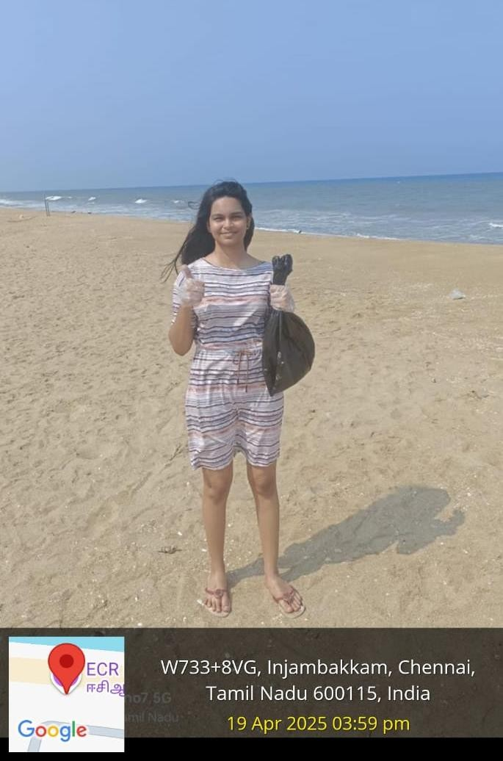

1

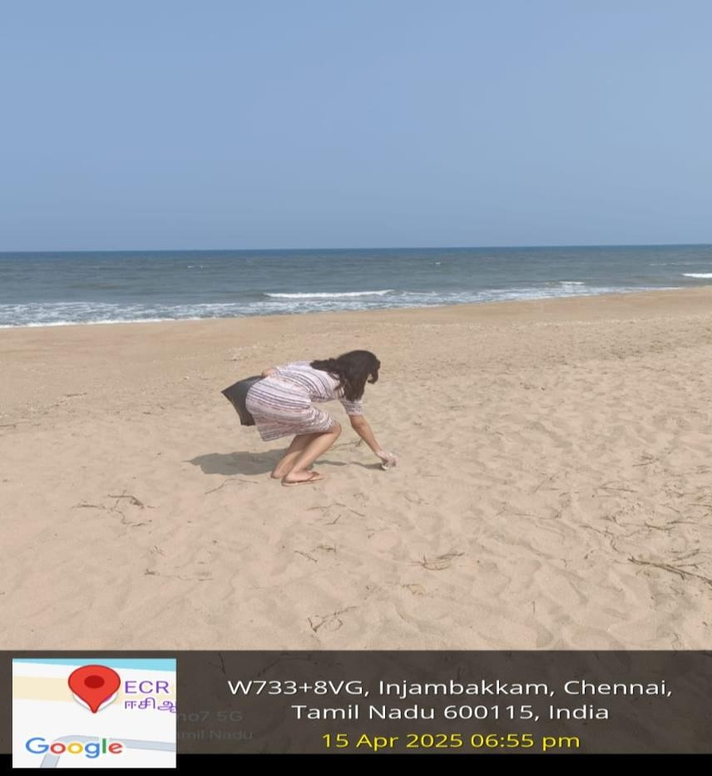

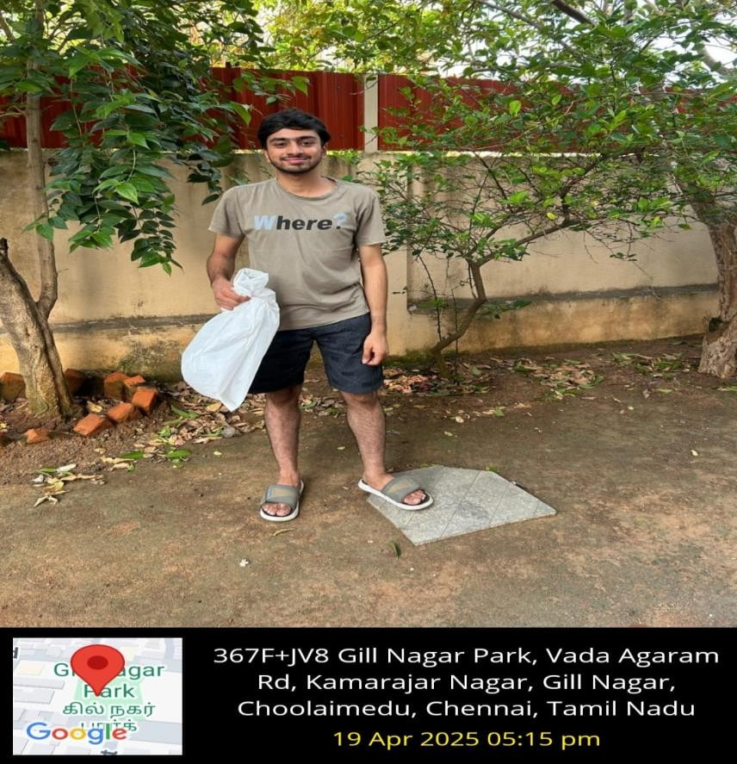

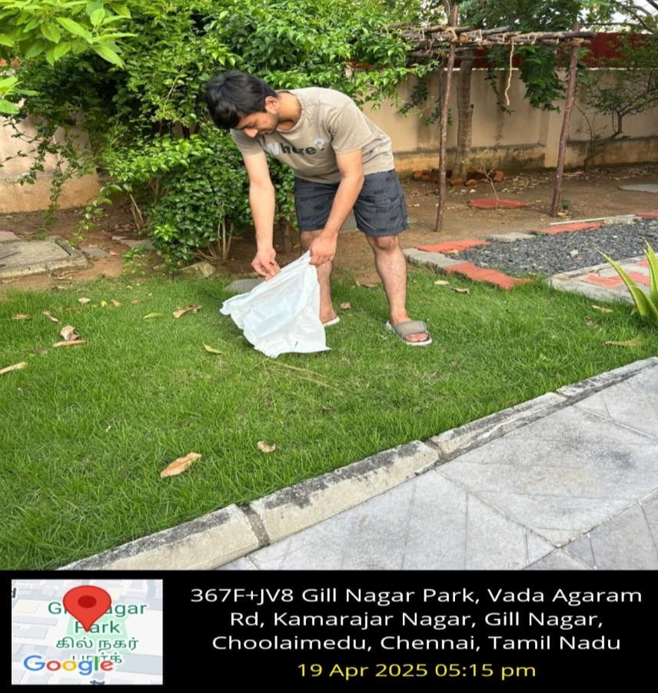

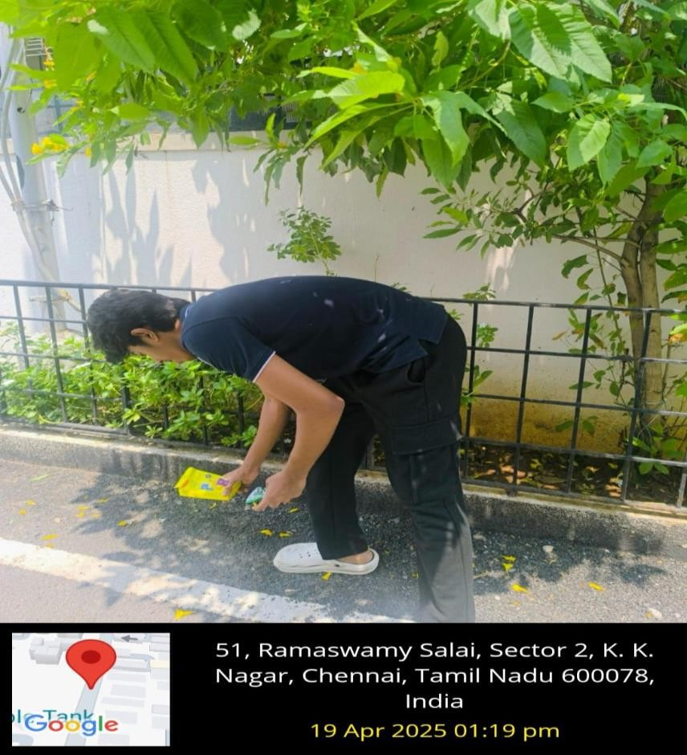

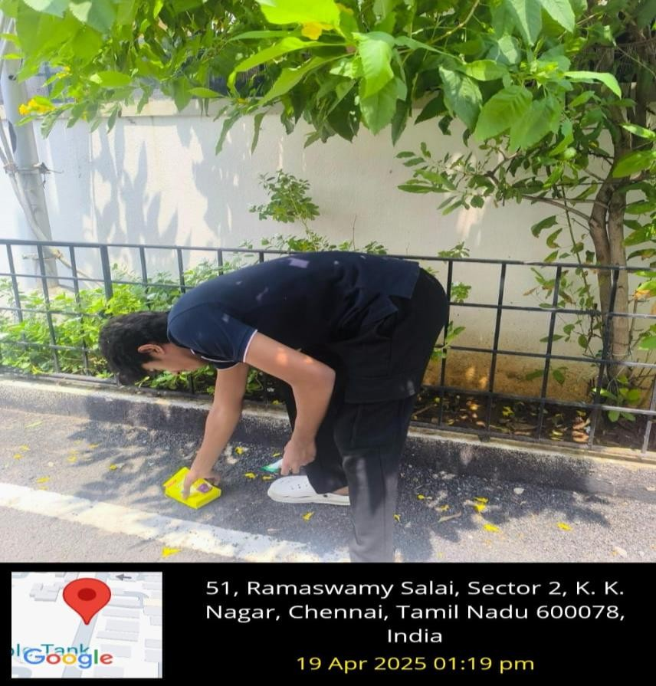

# ENVIRONMENTALLY RESPONSIBLE BEHAVIOR

## Socially Responsible Behaviour:

1. **Public Space Clean-Up –** We participated in cleaning drives across local parks, streets, and beaches to make shared spaces safer, healthier, and more pleasant for the community.
2. **Waste Segregation Awareness –** During the clean-up, we ensured proper segregation of biodegradable and non-biodegradable waste, helping in better waste management and recycling.
3. **Plastic Waste Reduction –** We actively avoided the use of single- use plastics and encouraged the use of reusable alternatives like cloth bags and bottles during the activity.t
4. **Community Engagement –** We shared our experience with peers and family to inspire them to take part in similar activities and adopt responsible habits toward public cleanliness.

## Environmentally Responsible Behaviour:

1. **Eco-Friendly Clean-Up Practices –** We used eco-safe methods and tools to clean areas without harming plants, soil, or water bodies.
2. **Upcycling Waste –** Items like discarded plastic bottles and containers were reused creatively as plant holders or storage, promoting sustainable reuse.
3. **Proper Waste Disposal –** Collected waste was carefully disposed of through appropriate municipal channels, ensuring minimal

environmental harm.

1. **Protecting Natural Habitats –** While cleaning parks and beaches, we took care not to disturb plants and wildlife, promoting coexistence and environmental respect.

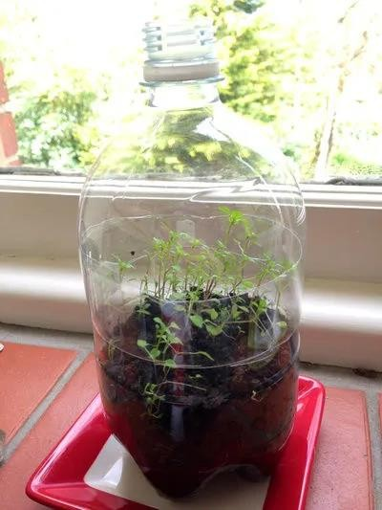





# CONCEPTUALISING HUMAN ETHICAL VALUES, HUMAN RELATIONSHIPS, AND HUMAN SOCIETY

## Comprehending Ethical Values

1. **Ethical Obligation towards the Environment –** Our clean-up activity reinforced our moral duty to care for public spaces and leave a cleaner world for future generations.
2. **Consistency and Responsibility –** We realized that maintaining cleanliness and protecting the environment require continuous effort and responsibility.
3. **Respect for Life –** Witnessing how litter affects plants, animals, and the beauty of nature heightened our appreciation for all forms of life.
4. **Integrity in Action –** Taking initiative to clean without expecting recognition highlighted the importance of honesty, integrity, and doing what’s right for the greater good.

## Understanding of Human Relationships

1. **Strengthening Bonds through Action –** Working alongside peers and community members helped us build trust, cooperation, and mutual respect.
2. **Family Involvement in Civic Responsibility –** Engaging family members in the clean-up encouraged shared learning and meaningful conversations about social and environmental duties.
3. **Developing Empathy and Compassion –** Contributing to cleaner surroundings nurtured empathy not only for people who live in those areas but also for those who maintain them.
4. **Exchanging Ideas and Perspectives –** Interacting with others during the project exposed us to new thoughts and practices, enriching our understanding of sustainability**.**

## Understanding of Human Society

1. **Recognizing the Power of Individual Actions –** Through simple efforts like picking up waste or spreading awareness, we saw how individual contributions can create visible change in society.
2. **Becoming Role Models –** By acting responsibly in public spaces, we inspired others to do the same and raised awareness about environmental cleanliness.
3. **Embracing Collective Responsibility –** The project highlighted that a healthy environment is a shared responsibility that requires participation from individuals, communities, and authorities.
4. **Realizing the Environment–Society Link –** Clean surroundings improve public health, safety, and community morale showing how environmental care directly supports societal well-being

# APPRECIATION AND ASPIRATION FOR EXCELLENCE AND GRATITUDE FOR ALL

## Appreciation for Nature

Our day outdoors made us appreciate the beauty and importance of keeping the environment intact. The mere observation of trees swaying in the wind or birds singing made us value nature more.

## Aspiration for Excellence in Our Efforts

This experience inspired us to be more consistent in our efforts. Whether through minimizing waste, growing more trees, or creating awareness, we intend to make green practices a part of our lifestyle.

## Gratitude Towards the Resources Provided by Nature

We gained an appreciation for the air we breathe, the water we drink, and the food we eat. This consciousness moved us to appreciate our consumption patterns and curtail unnecessary wastage.

## Gratitude for the Support and Encouragement from Others

During this experience, encouragement from the family, friends, and mentors kept us motivated to remain dedicated to environmental preservation. It confirmed that good change is simpler when done with

others.

# SUMMARY

Maintaining a clean environment is vital for the overall health and well-being of all living beings on Earth. In today’s world, increasing pollution, deforestation, and excessive use of natural resources have led to serious environmental issues such as climate change, poor air and water quality, and loss of biodiversity. To tackle these challenges, it is important that individuals, communities, and governments take proactive steps toward environmental conservation.

Key actions include reducing pollution by managing waste responsibly, conserving water and energy, recycling materials, minimizing the use of plastics, and supporting the use of renewable energy sources. Protecting natural habitats, planting trees, and adopting sustainable practices in daily life are also essential. Additionally, raising environmental awareness through education helps people understand the importance of their actions and encourages more eco-friendly behavior.

Ultimately, creating a clean environment is a shared responsibility. By working together and making conscious efforts, we can reduce the negative impact on our planet and ensure a greener, healthier, and more sustainable future for generations to come.